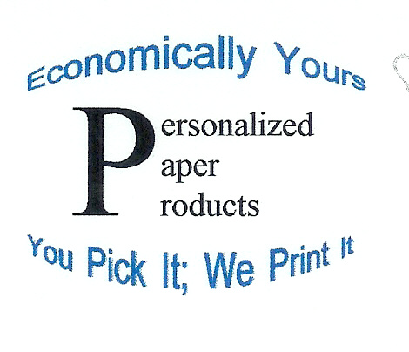
PRICE LIST

SHORT LAMINATED BANNER
2-page banner $2.00

More than two scanned photos is at least $3.00

BUSINESS CARDS
1 sheet—10 per page—Avery 5271 $1.00

ADDRESS LABELS
1 sheet—30 per page (best sellers)—Avery 5160 $1.00
1 sheet—20 per page—Avery 5161 $1.00

GREETING CARD WITH ENVELOPE
1 card—Can personalize any type of card (birthday, holiday) $1.00
Graduation Invitations for Seniors (can get two per card)

Add $1.00 for scanned photo

SIGNS OR FLYERS
10 sheets—8 ½ ” x 11”—Ideal for garage sales, advertising, etc. 10 for $1.00-$2.00*

A scanned photo increases the price

TRANSPARANCIES FOR TEACHERS

1 sheet—We can design transparency or $1.00 to 1.50*
we can make transparency from a pre-designed sheet.

LETTERHEAD OR STATIONERY
10 sheets—8 ½” x 11” personalized letterhead 10 for $1.00

POSTCARDS--INVITATIONS TO PARTIES, ETC.
1 sheet—4 per sheet or 2 per sheet (PrintShop) $1.00

NAME TAGS
1 sheet—8 per page (5390 perforated or 5395 peel-off) $1.00

CALENDAR
1 sheet—Can personalize a calendar with a scanned photo $1.00

If the item you want is not on the price list, ask us about it.

We do not enlarge photos and print on photo paper. We do scan photos to place on other documents.

*Price depends on how much color is used in design. A scanned photo can add to the price of an item.

